EE 5356_ DIGITAL IMAGE PROCESSING

ASSIGNMENT 9

NAME: PAVAI ARCHIMEDES

ST ID: 1001233996

LOW PASS AND HIGH PASS FILTER

Steps:

1. Read any 512*512 grayscale image and compute its Fourier transform.

2. Generate an ideal LPF for your 512*512 image with cutoff frequency (Do) 40, 60 and compute its frequency response .

3. Generate a Gaussian LPF with σ = 16, 24 and compute its frequency response.

4. Generate a Butterworth LPF having order n = 3, 4 and Do = 50 and compute its frequency response.

5. Generate an ideal HPF with cutoff frequency 30, 50 and compute its frequency response.

6. Generate a Gaussian HPF with σ = 16, 24 and compute its frequency response.

7. Generate a Butterworth HPF with n = 3, 4 and Do = 50 and compute its frequency response.

8. Apply all the generated filters on your image in frequency domain and obtain the filtered images.

Submit the following:

1. Display the image and the log of its shifted Fourier transform image (magnitude spectrum).

2. Display the 3D plot of all the LPF and HPF filter responses.

3. Display all the filtered images in frequency domain.

4. Display all the filtered images in spatial domain.

5. Give the MATLAB code.

References:

1. Marques, Oge “Practical image and video processing using MATLAB” pp 243-251, Wiley, 2011

MATLAB PROGRAM:

clc;

clear all;

close all;

I = imread('C:\Users\PAVAI ARCHIMEDES\Desktop\boat512.gif');

[m n]=size(I);

figure();

subplot(1,2,1);

imshow(im2double(uint8(I)));

title('original image');

I =im2double(I);

I_fft = fft2(I);

subplot(1,2,2);

imshow(log(1 + abs(fftshift(I_fft))));

title('DFT of original image');

ull = 0:(m-1);

vcc = 0:(n-1);

ipp = find(ull > m/2);

ull(ipp) = ull(ipp)-m;

j = find(vcc > n/2);

vcc(j)=vcc(j)-n;

[k,l]=meshgrid(vcc,ull);

D=sqrt((k.^2+l.^2));

figure();

mesh(real(fftshift(D)));

title('D(ull,vee)');

%%%LPF for cutoff frequency Do=40 %%

m=512;

n=512;

for ull = 1:m

for vcc = 1:n

if(D(ull,vcc) <= 40)

H1(ull,vcc) = 1;

else

H1(ull,vcc) = 0;

end

end

end

figure();

mesh(fftshift(H1)),

title('LPF for D0=40');

I1 = H1.*I_fft;

I1_ifft = real(ifft2(I1));

figure();

subplot(2,1,1);

imshow(log(1+abs(fftshift(I1))),[]);

title('filtered DFT image');

subplot(2,1,2);

imshow(I1_ifft);

title('filtered image');

%LPF for cutoff frequency Do=60 %

m=512;

n=512;

for ull = 1:m

for vcc = 1:n

if(D(ull,vcc) <= 60)

H2(ull,vcc) = 1;

else

H2(ull,vcc) = 0;

end

end

end

figure();

mesh(fftshift(H2)),

title('LPF for D0=60');

I2 = H2.*I_fft;

I2_ifft = real(ifft2(I2));

figure();

subplot(2,1,1);

imshow(log(1+abs(fftshift(I2))));

title('fil DFT image');

subplot(2,1,2);

imshow(I2_ifft);

title('fil image');

m=512;n=512;

for ull = 1:m

for vcc = 1:n

if(D(ull,vcc)<=30)

H3(ull,vcc) = 0;

else

H3(ull,vcc) = 1;

end

end

end

figure();

mesh(fftshift(H3)),

title('HPF for D0=30');

I3 = H3.*I_fft;

I3_ifft = real(ifft2(I3));

figure();

subplot(2,1,1);

imshow(log(1+abs(fftshift(I3))));

title('fil DFT image');

subplot(2,1,2);

imshow(I3_ifft);

title('fil image');

m=512;n=512;

for ull = 1:m

for vcc = 1:n

if(D(ull,vcc)<=50)

H4(ull,vcc) = 0;

else

H4(ull,vcc) = 1;

end

end

end

figure();

mesh(fftshift(H4)),

title('HPF for D0=50');

I4 = H4.*I_fft;

I4_ifft = real(ifft2(I4));

figure();

subplot(2,1,1);

imshow(log(1+abs(fftshift(I4))));

title('fil DFT image');

subplot(2,1,2);

imshow(I4_ifft);

title('fil image');

m=512;n=512;

for ull=1:m

for vcc=1:n

H5(ull,vcc) = 1/(1+(D(ull,vcc)/50)^(2*3));

end

end

figure();

mesh(fftshift(H5)),

title('Butterworth LPF for n=3, D0=50');

I5 = H5.*I_fft;

I5_ifft = real(ifft2(I5));

figure();

subplot(2,1,1);

imshow(log(1+abs(fftshift(I5))));

title('fil DFT image');

subplot(2,1,2);

imshow(I5_ifft);

title('fil image');

m=512;n=512;

for ull=1:m

for vcc=1:n

H6(ull,vcc) = 1/(1+(D(ull,vcc)/50)^(2*4));

end

end

figure();

mesh(fftshift(H6)),

title('Butterworth LPF for n=4, D0=50');

I6 = H6.*I_fft;

I6_ifft = real(ifft2(I6));

figure();

subplot(2,1,1);

imshow(log(1+abs(fftshift(I6))));

title('fil DFT image');

subplot(2,1,2);

imshow(I6_ifft);

title('filtered image');

m=512;n=512;

for ull = 1:m

for vcc = 1:n

H7(ull,vcc) = 1/(1+(50/D(ull,vcc))^(2*3));

end

end

figure();

mesh(fftshift(H7)),

title('Butterworth HPF for n=3, D0=50');

I7 = H7.*I_fft;

I7_ifft = real(ifft2(I7));

figure();

subplot(2,1,1);

imshow(log(1+abs(fftshift(I7))));

title('fil DFT image');

subplot(2,1,2);

imshow(I7_ifft);

title('fil image');

m=512;n=512;

for ull = 1:m

for vcc = 1:n

H8(ull,vcc) = 1/(1+(50/D(ull,vcc))^(2*4));

end

end

figure();

mesh(fftshift(H8)),

title('Butterworth HPF for n=4, D0=50');

I8 = H8.*I_fft;

I8_ifft = real(ifft2(I8));

figure();

subplot(2,1,1);

imshow(log(1+abs(fftshift(I8))));

title('fil DFT image');

subplot(2,1,2);

imshow(I8_ifft);

title('fil image');

m=512;n=512;

for ull = 1:m

for vcc = 1:n

H9(ull,vcc) = exp(-1*(D(ull,vcc)^2)/(2*16^2));

end

end

figure();

mesh(fftshift(H9)),

title('Guassian LPF for sigma=16');

I9 = H9.*I_fft;

I9_ifft = real(ifft2(I9));

figure();

subplot(2,1,1);

imshow(log(1+abs(fftshift(I9))));

title('fil DFT image');

subplot(2,1,2);

imshow(I9_ifft);

title('fil image');

m=512;n=512;

for ull = 1:m

for vcc = 1:n

H10(ull,vcc) = exp(-1*(D(ull,vcc)^2)/(2*24^2));

end

end

figure();

mesh(fftshift(H10)),

title('Guassian LPF for sigma=24');

I10 = H10.*I_fft;

I10_ifft = real(ifft2(I10));

figure();

subplot(2,1,1);

imshow(log(1+abs(fftshift(I10))));

title('filtered DFT image');

subplot(2,1,2);

imshow(I10_ifft);

title('filtered image');

m=512;n=512;

for ull = 1:m

for vcc = 1:n

H11(ull,vcc) = 1-exp(-1*(D(ull,vcc)^2)/(2*16^2));

end

end

figure();

mesh(fftshift(H11)),

title('Guassian HPF for sigma=16');

I11 = H11.*I_fft;

I11_ifft = real(ifft2(I11));

figure();

subplot(2,1,1);

imshow(log(1+abs(fftshift(I11))));

title('fil DFT image');

subplot(2,1,2);

imshow(I11_ifft);

title('fil image');

m=512;n=512;

for ull = 1:m

for vcc = 1:n

H12(ull,vcc) = 1-exp(-1*(D(ull,vcc)^2)/(2*24^2));

end

end

figure();

mesh(fftshift(H12)),

title('Guassian HPF for sigma=24');

I12 = H12.*I_fft;

I12_ifft = real(ifft2(I12));

figure();

subplot(2,1,1);

imshow(log(1+abs(fftshift(I12))));

title('fil DFT image');

subplot(2,1,2);

imshow(I12_ifft);

title('fil image');

RESULTS:

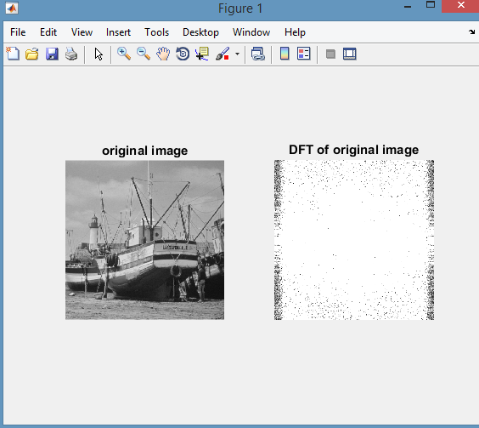

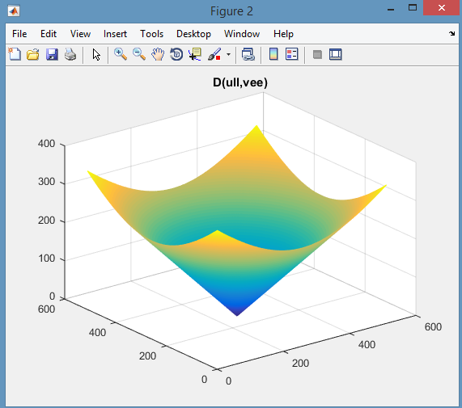

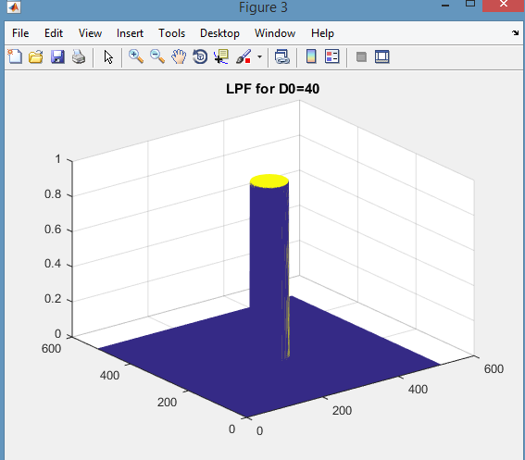

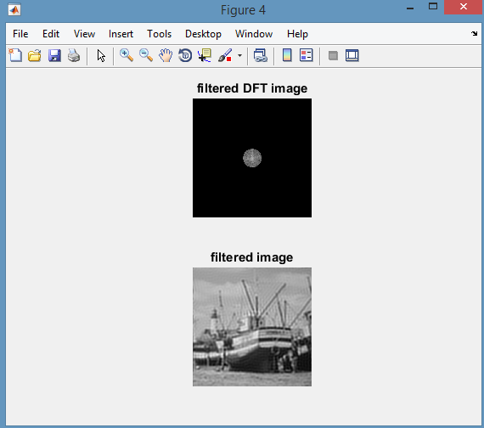

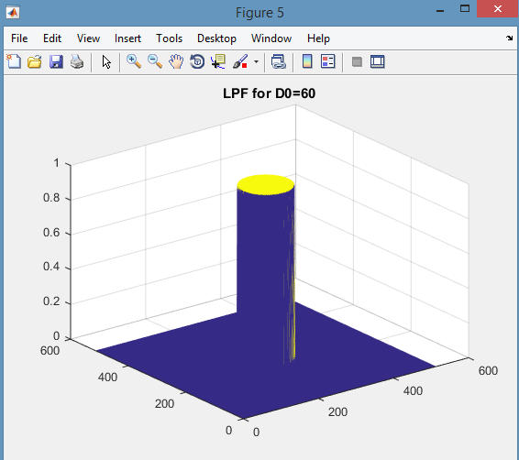

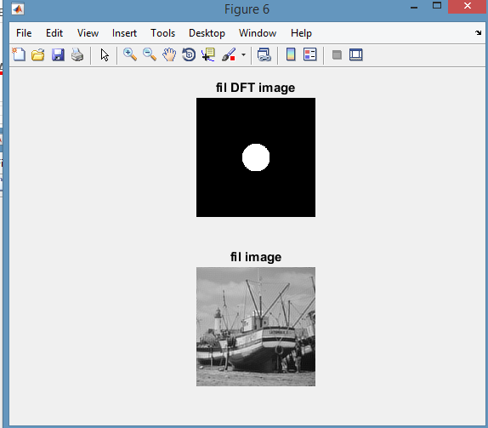

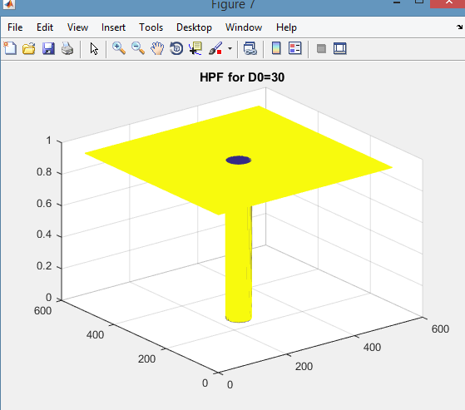

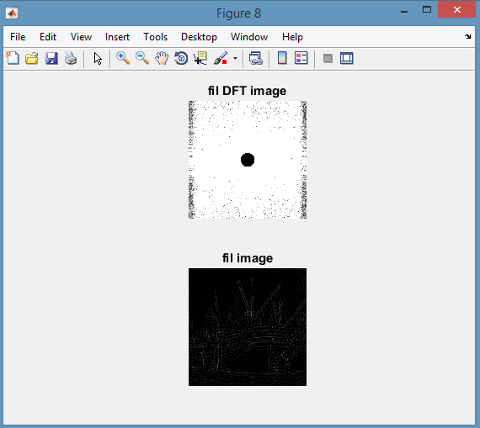

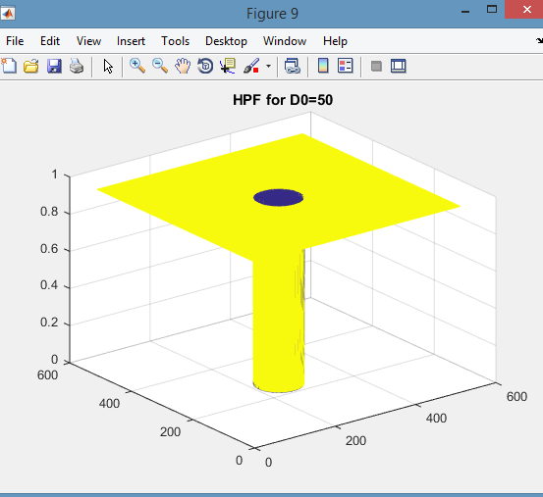

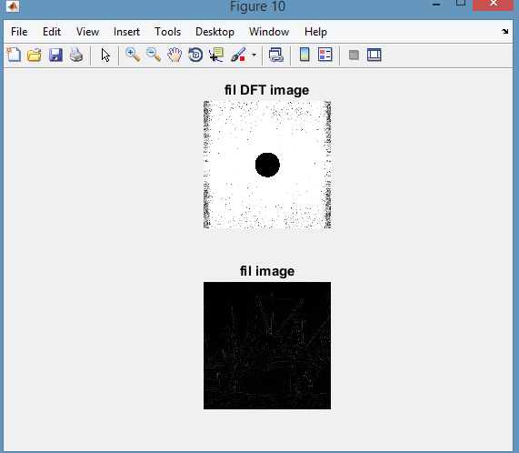

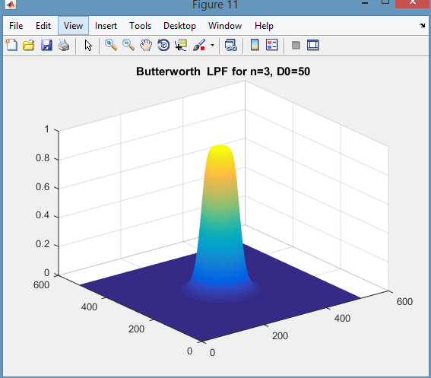

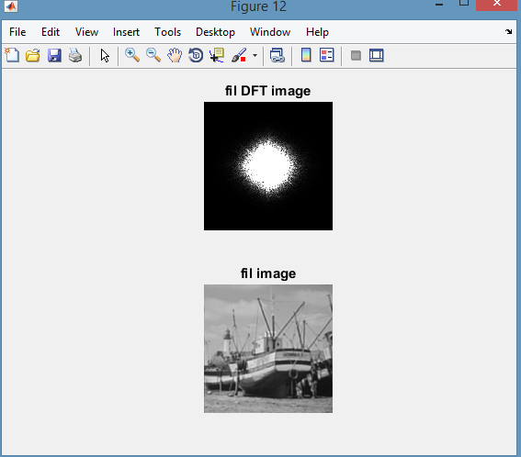

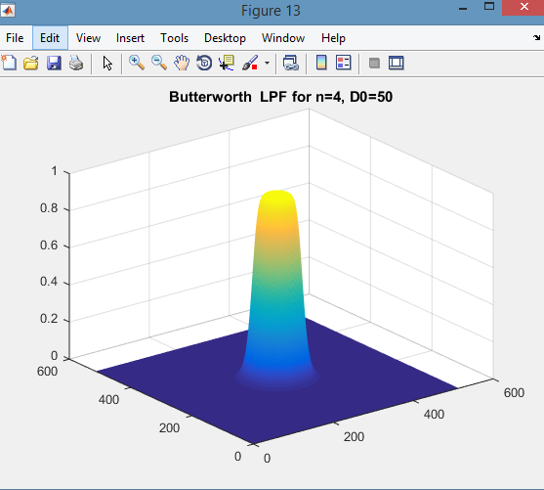

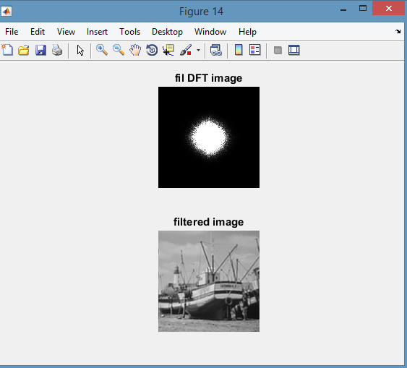

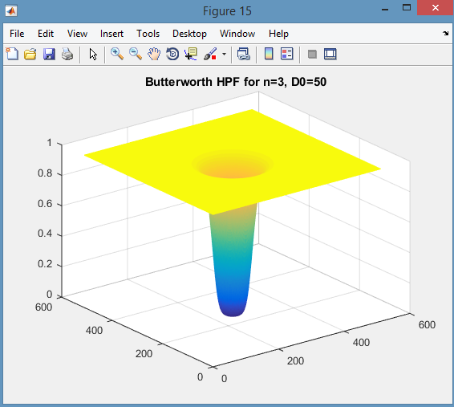

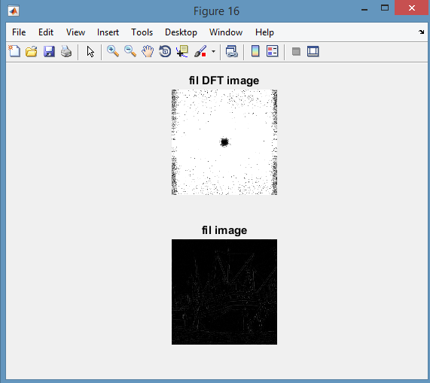

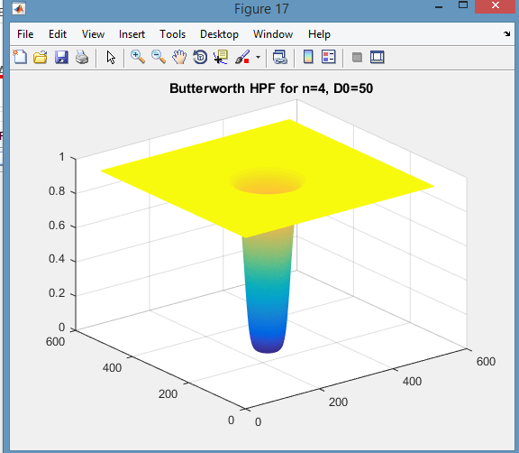

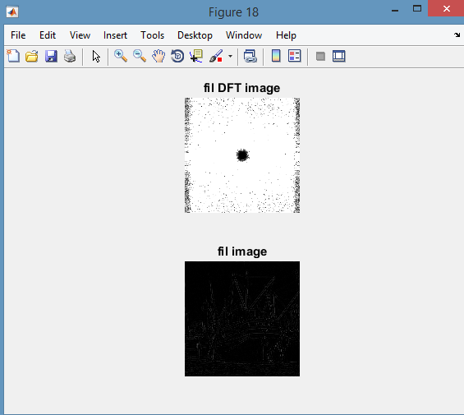

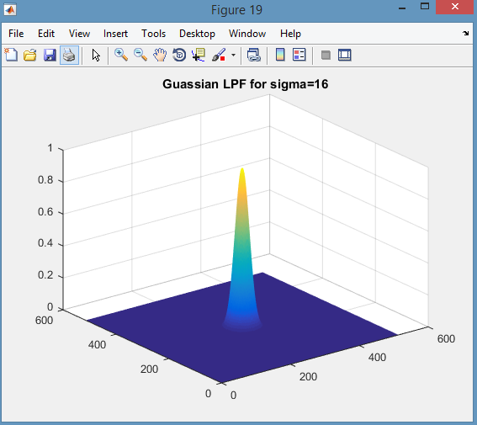

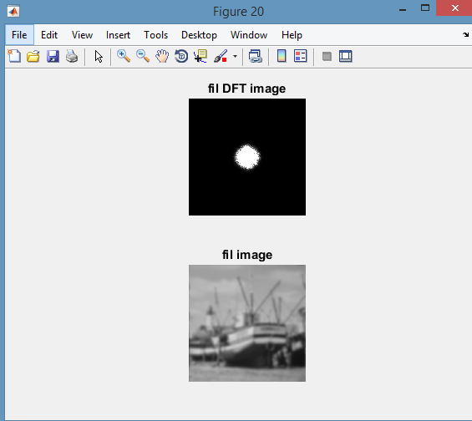

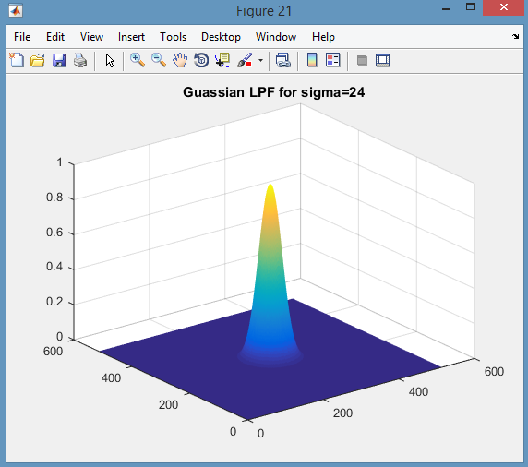

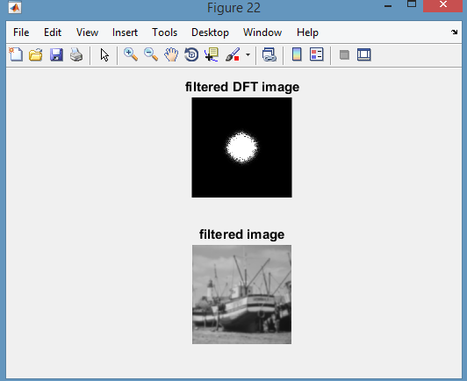

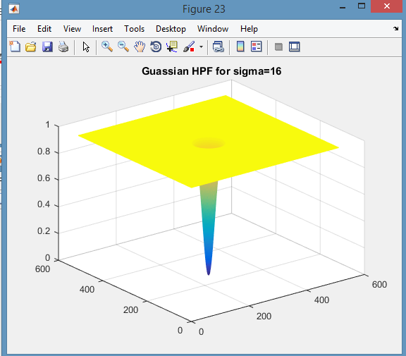

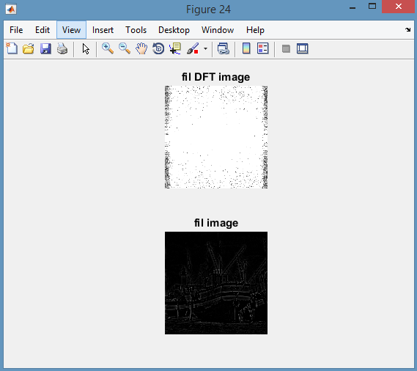

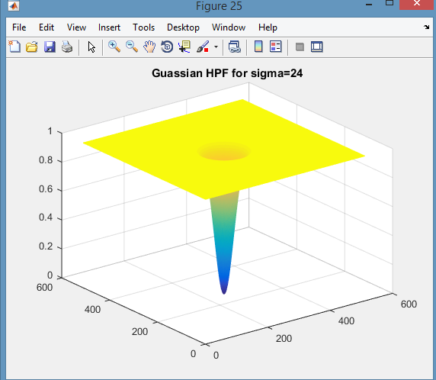

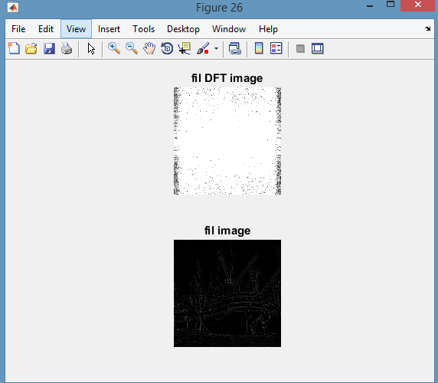

CONCLUSION:

All the required filter has been designed and applied on the test image.